Project Title: PickMelast

Project Group : 4

Project Team Members: Hari, Josh, Herbirt

Features in this Increment:

1. FireBase Eauth Google Login
2. Game CRUD function fully implemented
3. Weather Forecast for the game Implemented almost 90%
4. Login Safeguard Implemented successfully.

Login Page: Login page is Default page, Users will be directed to. User will be able to login using google account. Once user logged in, user will see view screen with welcome page.

User will get error message if authentication fails.

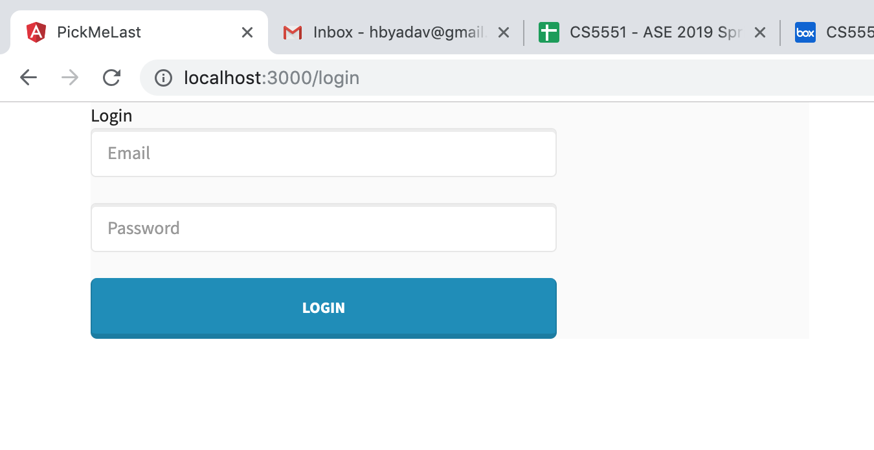

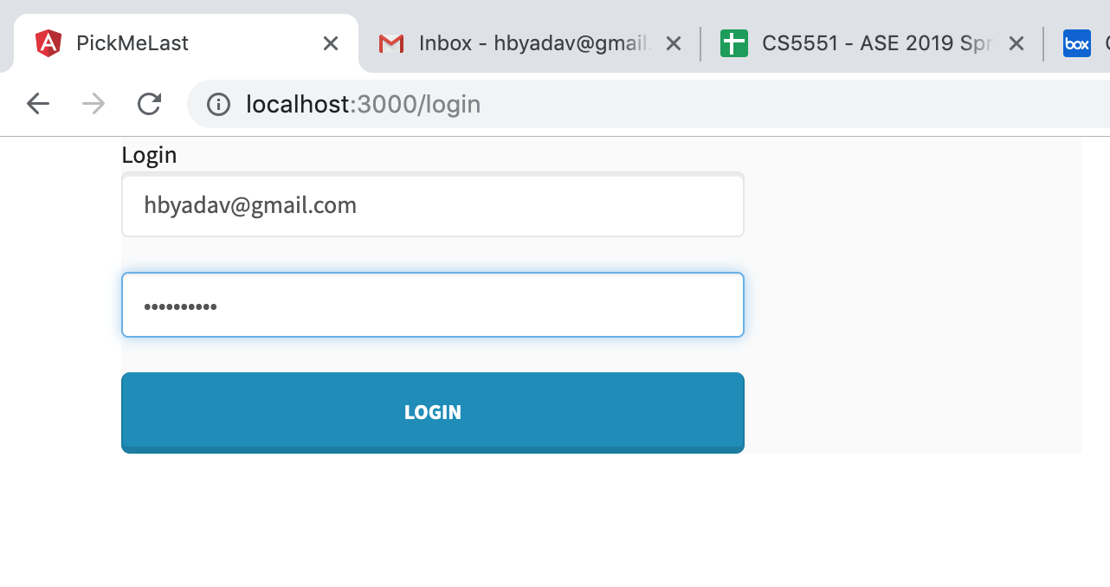

View page:

After successfully logging in, user will see the below screen with all games scheduled.

User will be able to view, add, edit and delete the game as well as enroll into the game.

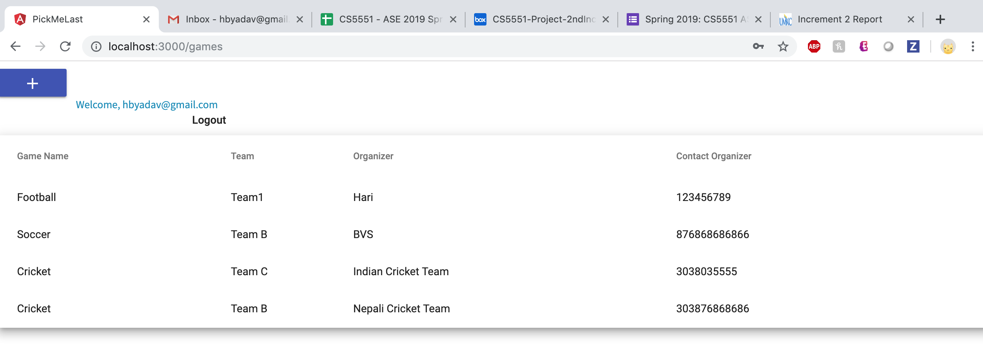

Add Screen,

User will be able to add the screen as below screen. Add Form has validation which will, validate whether data been provided or not. User will get error message if field validation fails. Save button will be active once form validation passes.

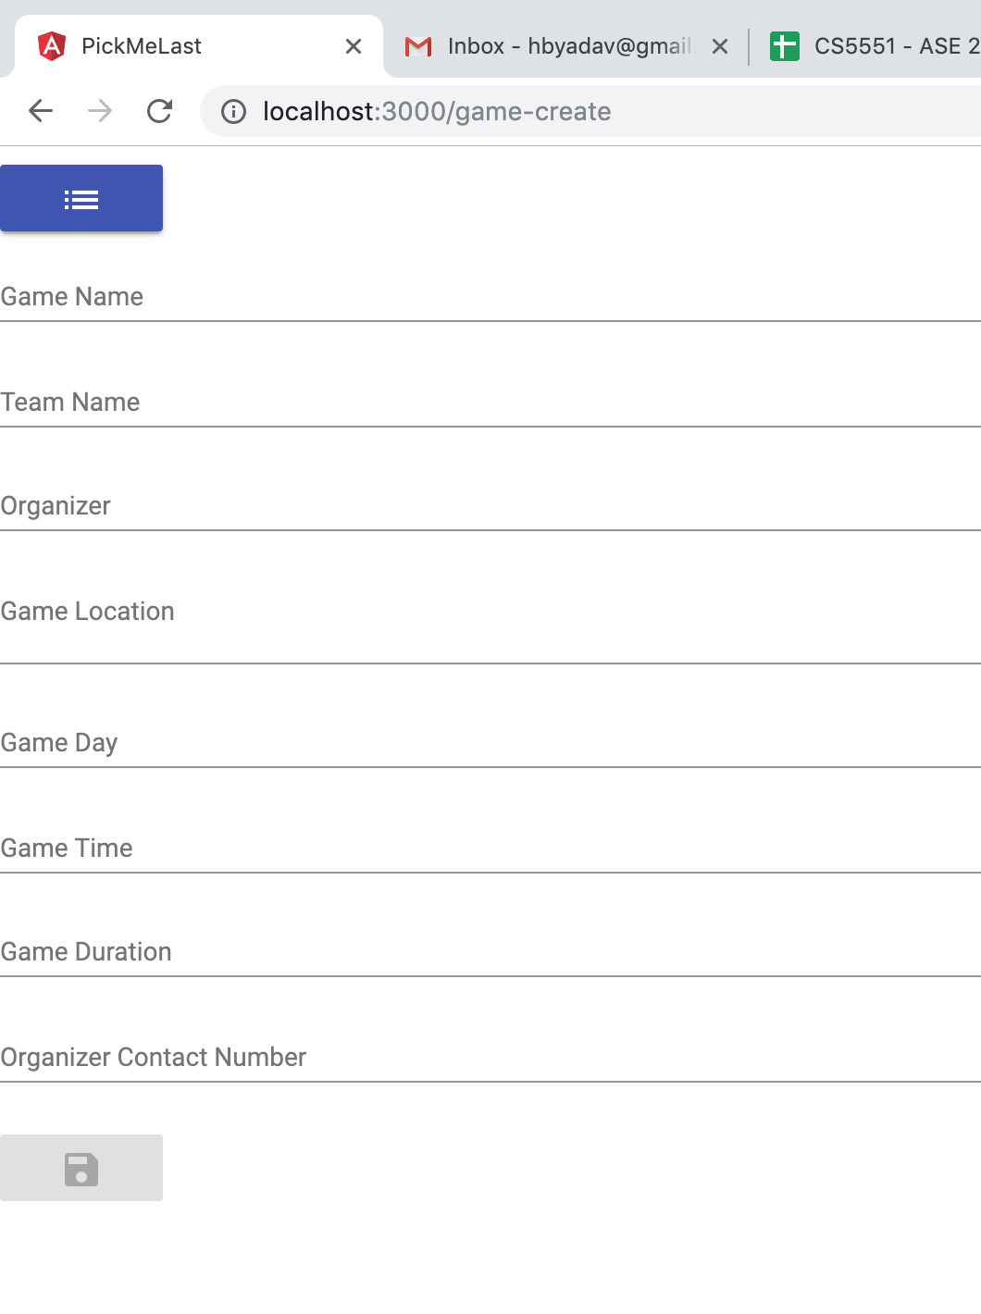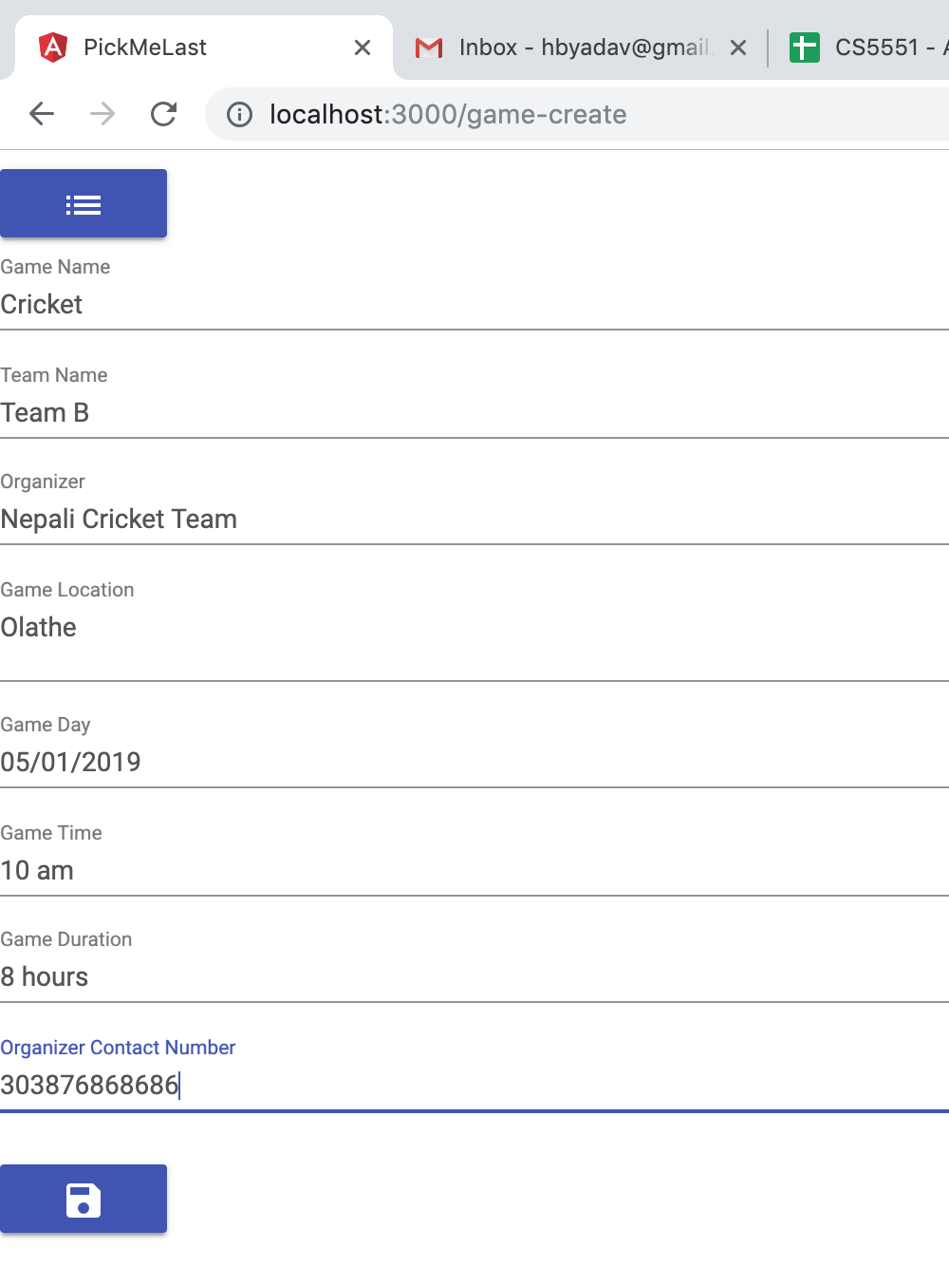

Detail View page:

User will be able to navigate to View Detail page to view the detail information about the game. User is allowed to see the Weather information on detail page. User will be allowed to edit or delete the game if he is authorized to do so.

User will be able to enroll in to the game via this page. Feature is not 100% implemented at this increment.

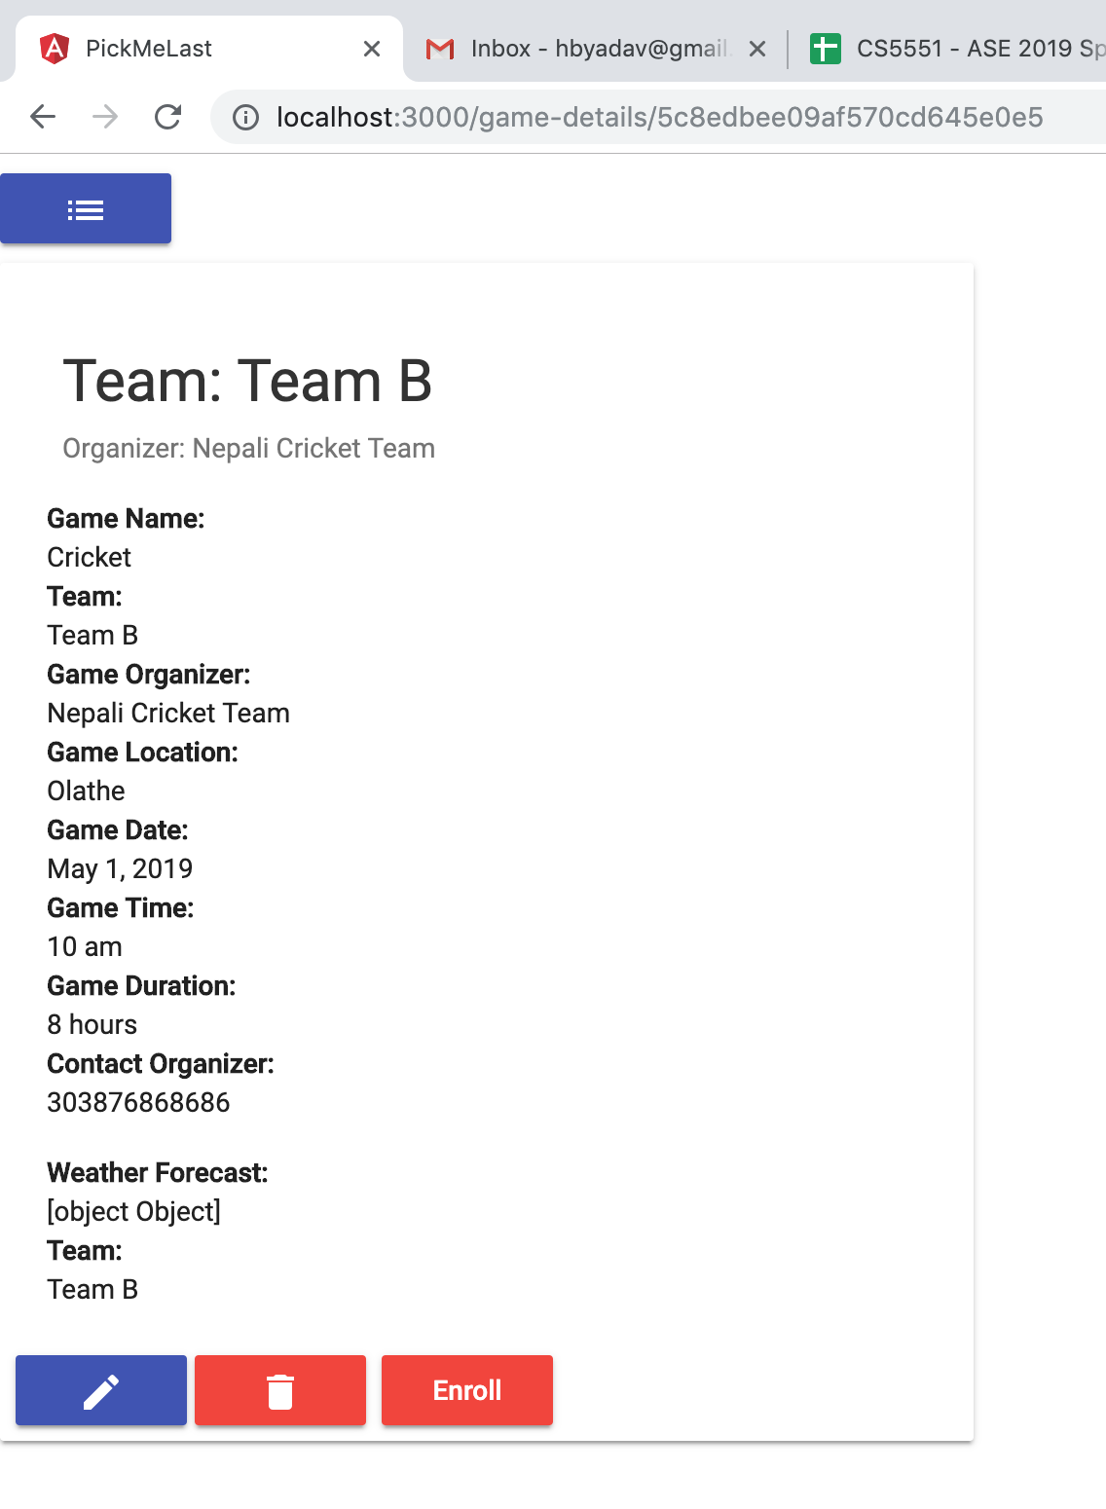

After submitting the Edi form, User will see the updated View page with current change.

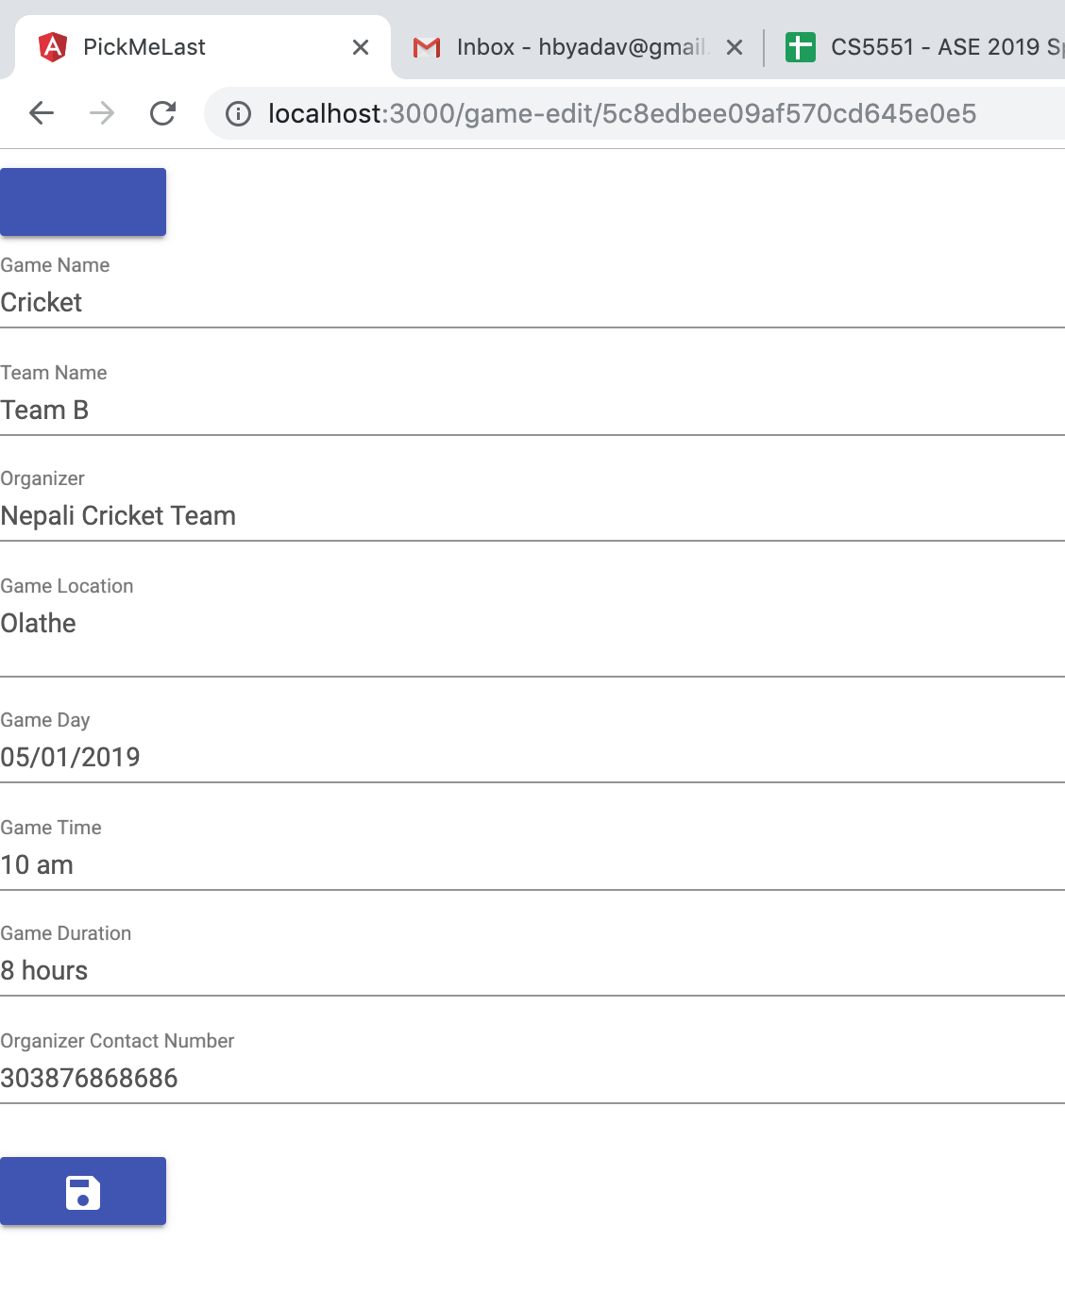

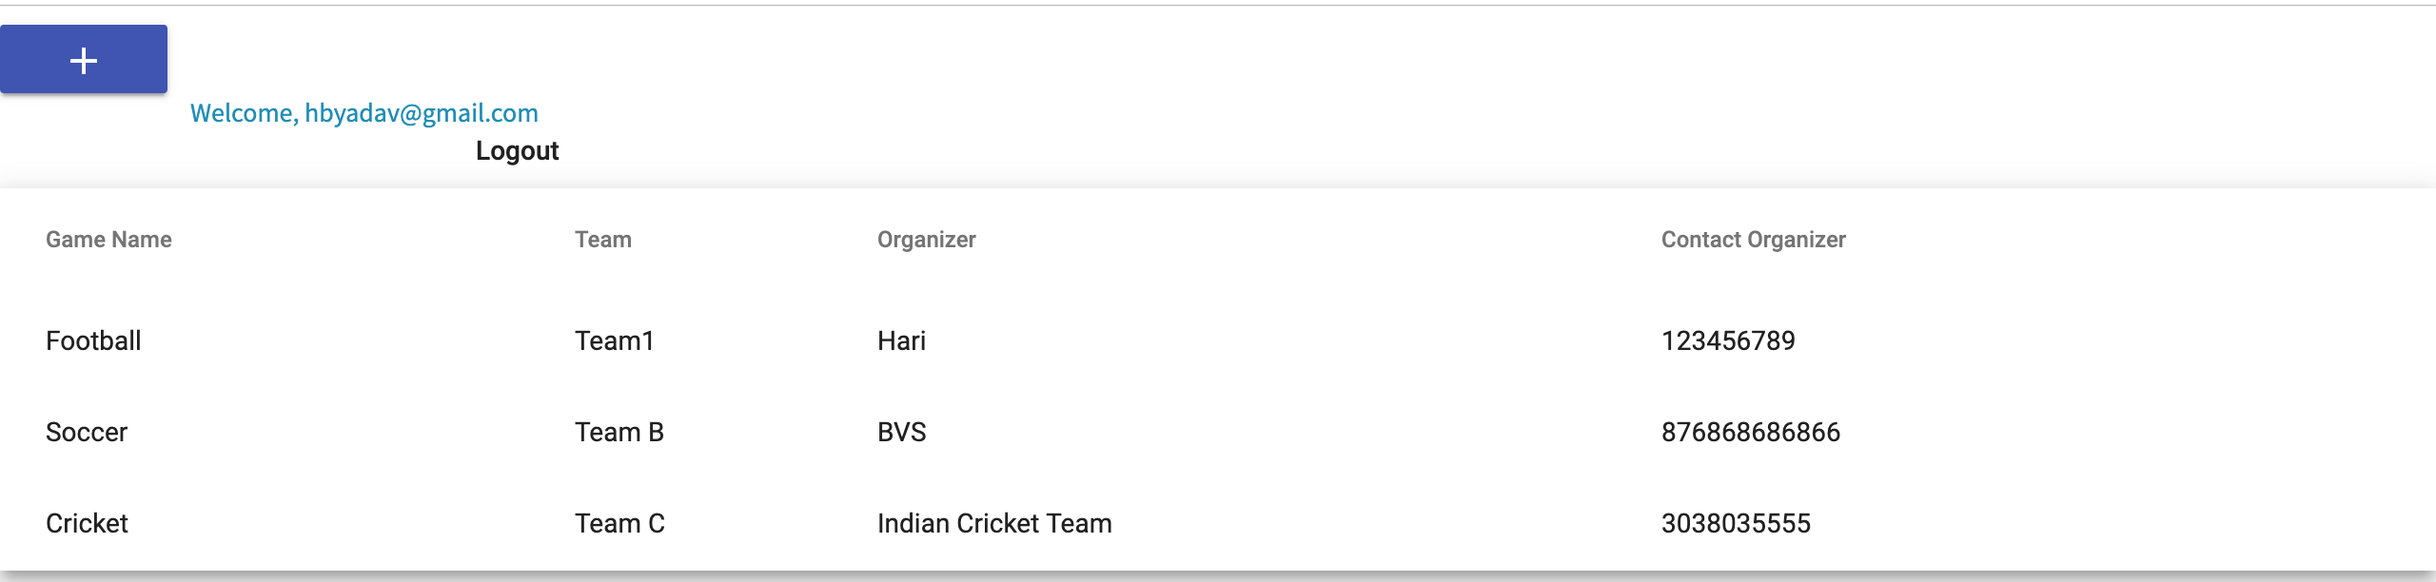

Logout Function:

User will see the logout button on upper right corner of the home page. After clicking the button, User will be logged out and directed to the home page as shown below.



Below is the Screen shot attached for error I got while implementing weather api.